LATE BEETHOVEN
John Gibbons, john@holdekunst.com

Description
This course will examine the evolution of Beethoven’s late works. In addition to the music itself, we will focus on the sociological, political, and philosophical interactions between Beethoven’s work and the turbulent events of his era, such as the French Revolution and the Napoleonic wars. Ultimately, the course aims to foster the acquisition of a deep sense of context for the listener and to provide students with the skills and strategies needed for a deeper understanding of Beethoven’s late symphonies and quartets.

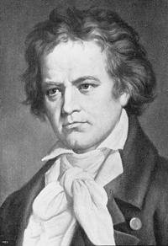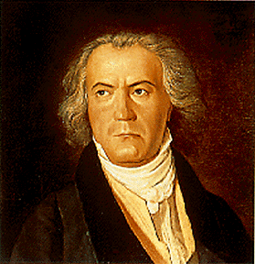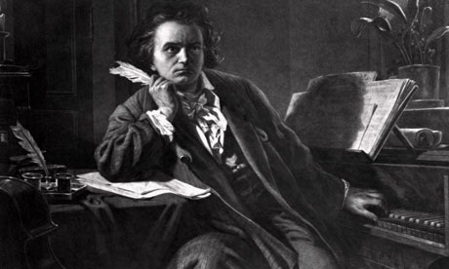

Brief Biography of Beethoven
Ludwig van Beethoven was born in 1770 in Bonn, Germany. His father was also a musician and had dreams of young Ludwig becoming the next Mozart. Beethoven visited Vienna at age 17 and made it his home five years later. There he studied under Haydn, as well as Schenk, Albrechtsberger and Salieri. A virtuoso pianist, Beethoven quickly gained the patronage of Vienna's aristocracy and thereafter became what might be called the first great freelance composer. Around 1802 Beethoven realized that he was losing his hearing but kept working and attempted to keep his disability a secret. By 1812 he had fallen into a deep depression over his hearing loss, other medical problems and romantic disappointments. But the artist in him soldiered on, producing some of the finest masterpieces in all of classical composition in his late period. Beethoven died in Vienna in 1827 with over 10,000 people attending his funeral.

Beethoven’s Three Periods
Beethoven's compositional career is usually divided into Early, Middle, and Late periods. In this scheme, his early period is taken to last until about 1802, the middle period from about 1803 to about 1814, and the late period from about 1815.
In his Early period, Beethoven's work was strongly influenced by his predecessors Haydn and Mozart. He also explored new directions and gradually expanded the scope and ambition of his work. Some important pieces from the Early period are the first and second symphonies, the set of six string quartets Opus 18, the first two piano concertos, and the first dozen or so piano sonatas, including the famous Pathétique sonata, Op. 13.
His Middle (Heroic) period began shortly after Beethoven's personal crisis brought on by his recognition of encroaching deafness. It includes large-scale works that express heroism and struggle. Middle-period works include six symphonies (Nos. 3–8), the last three piano concertos, the Triple Concerto and violin concerto, five string quartets (Nos. 7–11), several piano sonatas (including the Moonlight, Waldstein and Appassionata sonatas), the Kreutzer violin sonata and Beethoven's only opera, Fidelio.
Beethoven's Late period began around 1815. Works from this period feature great intellectual depth, formal innovations, and intense, highly personal expression. The String Quartet, Op. 131 has seven linked movements, and the Ninth Symphony adds choral forces to the orchestra in the last movement. Other compositions from this period include the Missa Solemnis, the last five string quartets (including the massive Große Fuge) and the last five piano sonatas.
This course examines the unique characteristics of Beethoven’s final period with its increasingly personal yet loftily philosophical character. These works occupy a unique status in Western art. Deep intellectuality is combined with humility and gentleness to create an aura of transcendence.
Week 1 | String Quartet, Op. 95 (1810)  Violin Sonata, Op. 96 (1812-1815)  Piano Sonata, Op. 90 (1814) | Week 5 | Variations on a Theme by Diabelli for Piano,  Op. 121 (1823)  Ninth Symphony, Op. 125 (1823)
Week 2 | Cello Sonatas, Op. 102 (1815)  Piano Sonata, Op. 101 (1816)  An die ferne Geliebten, Op. 98 (1816) | Week 6 | String Quartet Op. 127 (1823-1824)  String Quartet Op. 130 (1825-1826)  String Quartet Op. 132 (1825)
Week 3 | Sonata Op. 106 (1818)  Bagatelles, Op. 119 (1820-1822)  Bagatelles, Op. 126 (1823-1823) | Week 7 | Missa Solemnis, Op. 123 (1823)
Week 4 | Sonata, Op. 109 (1820)  Sonata, Op. 110 (1821)  Sonata, Op. 111 (1821-1822) | Week 8 | String Quartets Op. 131 (1826)  Große Fuge for String Quartet,  Op. 133 (1825-1826)  String Quartets Op. 135 (1826)

Recommended Readings

Beethoven (Master Musicians Series),
by Barry Cooper
Beethoven, by William Kinderman
The Beethoven Quartets, by Joseph Kerman
The Classical Style: Haydn, Mozart, Beethoven, by Charles Rosen
Late Beethoven: Music, Thought, Imagination,
by Maynard Solomon
Music Sounded Out: Essays, Lectures, Interviews, Afterthoughts, by Alfred Brendel
Playing the Beethoven Piano Sonatas,
by Robert Taub
Wagner on Conducting, by Richard Wagner
The Beethoven Quartet Companion,
ed. Robert Winter, Robert Martin
Beethoven: Anguish and Triumph, by Jan Swafford

