Graham School of General Studies

20th Century Music
John Gibbons ~ 708-393-9729 ~ john@holdekunst.com

Description: Twentieth-century music is no longer “contemporary” music; it is becoming possible to put this complex and multifaceted century into context. We can now examine with reasonable objectiveness the influence and permanence of a diverse range of composers, from the once-radical (Schoenberg, Varese) to the once-reactionary (Rachmaninov, Copland) to the various “isms”: primitivism (Prokofiev, Orff), neoclassicism (Stravinsky, Les Six), minimalism, postminimalism, and neospirituality (Reich, Adams, Gorecki). Also included will be those figures defying classification, such as Shostakovich, Britten, Bartok, and Hindemith.
Week | Biographical and Historical Themes | Featured Works
1 | Mahler and Strauss | Mahler: Symphonies 2, 6  Das Lied von der Erde  Strauss: Salome and Elektra
2 | Debussy, Ravel, Satie, Milhaud | Debussy: La Mer; Pelléas and Mélisande  Ravel: L'enfant et les sortilèges  Saite: piano works  Milhaud: neoclassic and Brazilian works
3 | Scriabin, Stravinsky, Messiaen | Scriabin: Le Poème de l'extase, Prometheus, Poem of Fire  Stravinsky: Le Sacre du printemps  Messiaen: Vingt Regards
4 | Second Viennese School: Schoenberg, Berg, Webern, Hindemith | Various works from each composer showing their styles.
5 | American Century: Ives, Varèse, Copland | Ives: Concord Sonata  Varèse: Amériques  Copland: Appalachian Spring , Cowboy works
6 | The Russians: Rachmaninov, Prokofiev, Shostakovich | Prokofiev: Romeo and Juliet; War and Peace  Shostakovich: Symphonies and Quartets  Rachmaninov: Rhapsody on a Theme by Paganinni; Songs
7 | Eastern Europe: Janáček, Kodály, Bartók | Janáček: From the House of the Dead  Kodály: various works  Bartók: Concertos, ballets, operas
8 | Minimalism & Neospirituality: Glass, Reich, Adams, Pärt, Górecki | Glass: various works  Reich: Different Trains  Adams: various works including Dr. Atomic  Pärt: Berlin Mass  Górecki: Symphony No. 3: “Sorrowful Songs”

Recommended Books
Taruskin, Richard: Oxford History of Western Music vol. 4-5
Ross, Alex: The Rest Is Noise

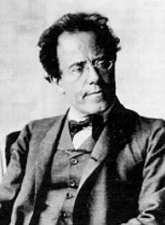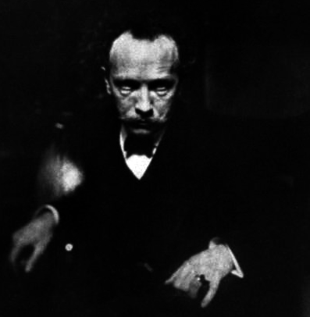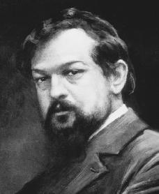
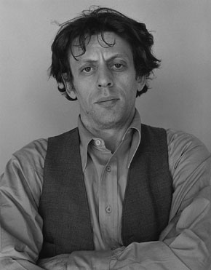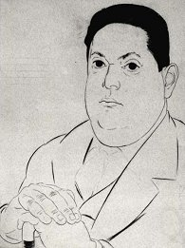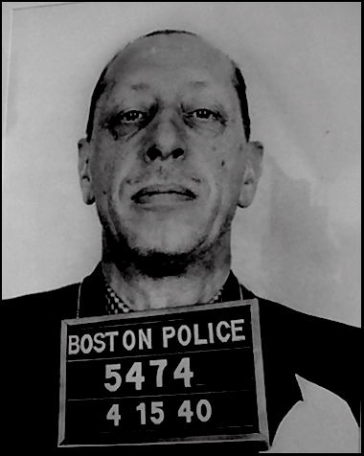
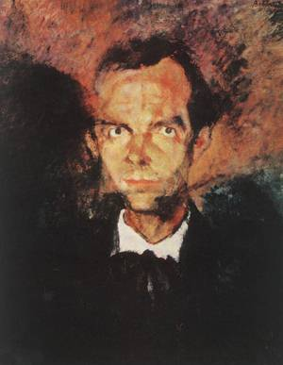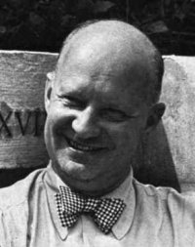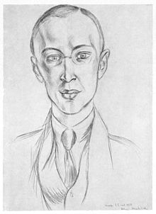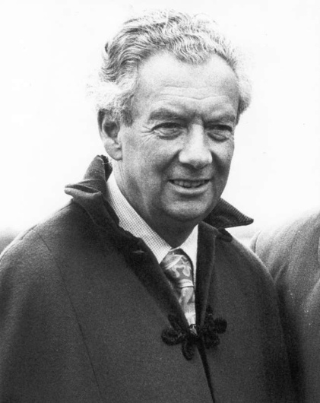
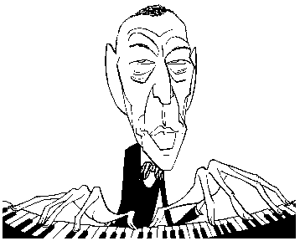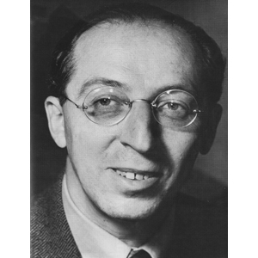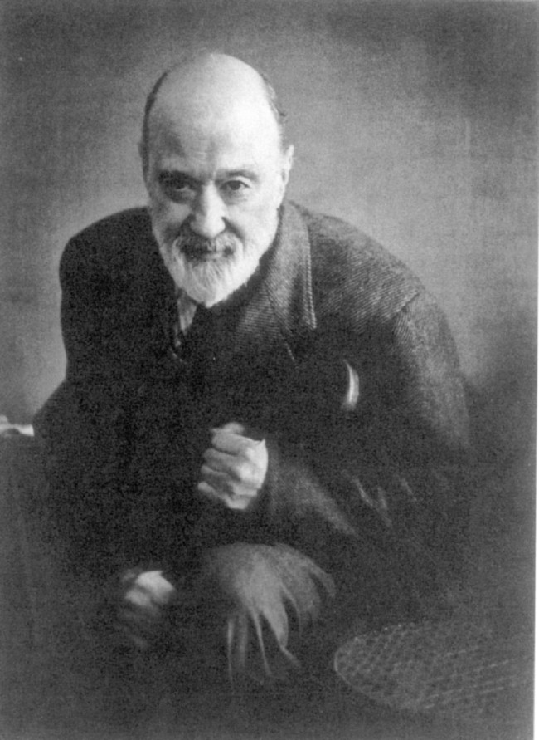
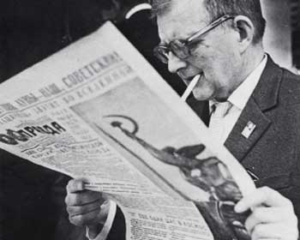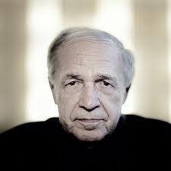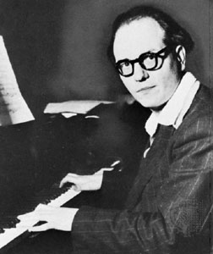
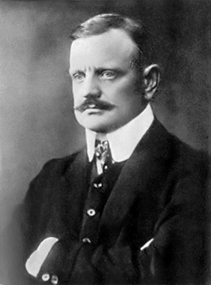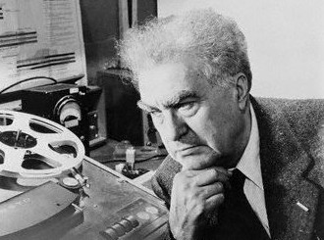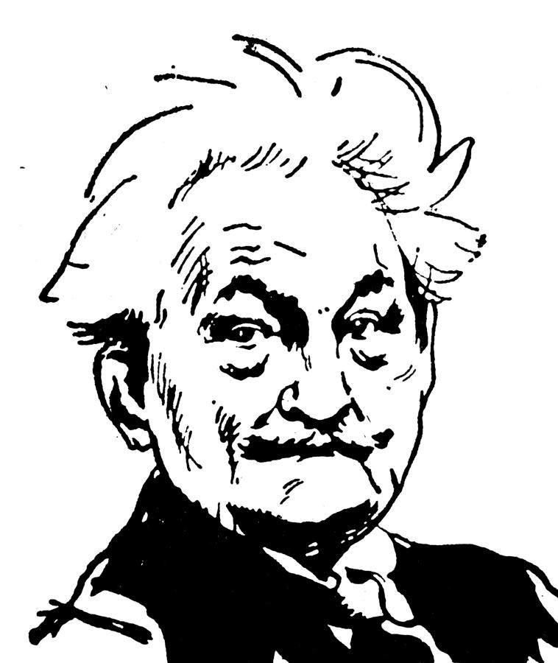

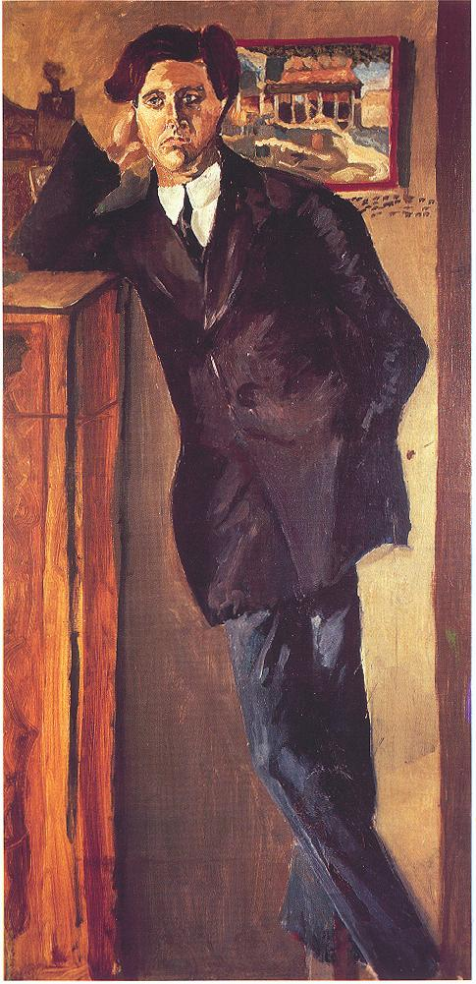 | 