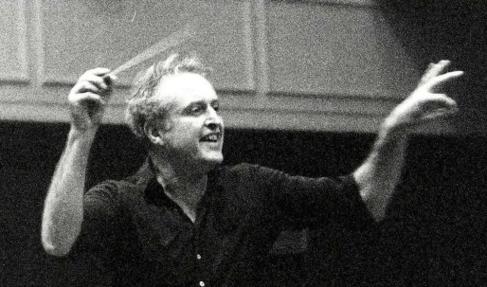 | 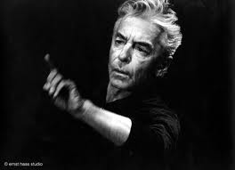
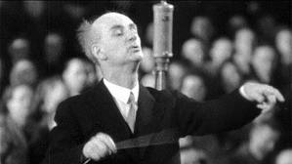 | 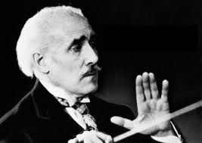
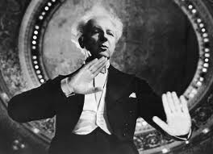 | 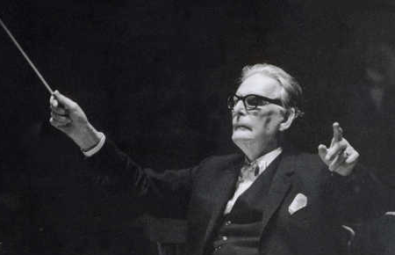
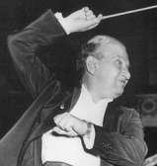 | 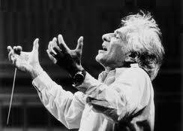
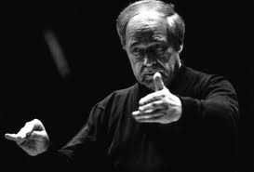
The Great Conductors Parts 1 and 2
John Gibbons
This course offers an overview of some of the great and frequently notorious conductors of the historical and modern eras. Especially useful for those who collect recordings, this course will educate participants in perceiving the essential characteristics that distinguish different interpreters of symphonic and operatic repertory. The richly anecdotal and highly eccentric nature of the subject will not be ignored, but the enormous difficulties of producing meaningful performances will be examined as well.
Reference Materials
Video: The Art of Conducting: Great Conductors of the Past
Conductors in conversation: fifteen contemporary conductors ... By Jeannine Wagar
Conductors on Conducting by Barry Jacobson
Conducting Technique: For Beginners And Professionals, By Brock McElheran
The Composer's Advocate: A Radical Orthodoxy for Musicians; Erich Leinsdorf on Music, By Erich Leinsdorf
The Furtwängler Record, By John Ardoin, John Hunt
Leopold Stokowski, a profile, By Abram Chasins
The Great Conductors, By Harold C. Schonberg
The Compleat Conductor, By Gunther Schuller
Recording the Classics: Maestros, Music, and Technology, By James Badal
Conversations With Klemperer, Ed. Peter Heyworth
Findings; The Joy of Music, By Leonard Bernstein
Orientations: Collected Writings, By Pierre Boulez, Jean-Jacques Nattiez, Martin Cooper
Part 2
Week | Maestri of the Week | Featured Selections | Conduct-Off
1 | Willem Mengelberg  Erich Kleiber  Adrian Boult  Thomas Beecham | Music by R. Strauss, J. Strauss, Elgar and Delius | Beethoven 6th Symphony, 1st mvt, exposition  Furtwängler, Gardiner, Toscanini, Brüggen
2 | Wilhelm Furtwängler  Sergiu Celibidache  Daniel Barenboim | Music by Wagner, Strauss, Debussy, and Bruckner | Mahler, 1st Symphony, first mvt, exposition  Mitropoulos, Kubelík, Solti, Abbado
3 | Dmitri Mitropoulos  Erich Leinsdorf | Music by Wagner, Schumann, Franck, Krenek | Tchaikovsky 5th Symphony, beginning of Finale  Gergiev, Muti, Karajan
4 | Charles Munch  Rafael Kubelík | Music by Berlioz, Mahler, Smetana | Debussy, Prelude to the afternoon of a faun  Dutoit, Stokowski, Boulez
5 | John Eliot Gardiner  Nikolaus Harnoncourt  Harry Bickett | Music by Bach, Brahms, Handel, Monteverdi | Sibelius 5th Symphony, Finale  Vänskä, Karajan, Gibson
6 | James Levine  Claudio Abbado  Georg Solti | Music by Mozart, Mahler | Berlioz, “A Ball” from Symphonie Fantastique  Colin Davis (Amsterdam), Colin Davis (London), Tilson Thomas
7 | Evgeny Mravinsky  Antol Dorati | Music by Shostakovich, Tchaikovsky, Kodaly | Brahms Requiem, 2nd mvt  Karajan, Giulini, Levine, Klemperer
8 | Gustavo Dudamel  Valery Gergiev | Music by Mahler, Prokofiev, Stravinsky, Rimsky-Korsakov | Vaughan Williams, 5th Symphony, beg.  Andrew Davis, Boult, Previn, Bakeels

What This Class Covered in Part 1 (For Your Information)
Maestro of the Week | Readings | Featured Selections | Conduct-Off
Herbert von Karajan | Conductors in Conversation;  Conducting Technique | Verdi: Requiem | Beethoven: 9Th Symphony 3rd mvt exposition  Furtwängler, Karajan, Zander, et al  Mahler: 4th Symphony, 1st mvt, exposition  Tennstedt, Kubelík
Carlos Kleiber | The Composer’s Advocate;  Leinsdorf on Music | Beethoven: Coriolanus Ov.  Brahms: 4th Symphony | Brahms: 4th Symphony 1st mvt exposition  Furtwängler, Karajan, Sawallisch  Bruckner: 7th Symphony 1st mvt exposition  Giulini, Karajan, Wand, Barenboim
Wilhelm Furtwängler | The Furtwängler Record | Wagner Meistersinger Ov. | Wagner: Siegfried’s Funeral Music  Furtwängler, Levine, Knappertsbusch, Boulez  Schubert Symphonies 8,9 (mvt TBD)  Masur, Walter
Arturo Toscanini, Leopold Stokowski | Leopold Stokowski: A Profile;  The Great Conductors | Beethoven: Piano concertos 3 & 5 | Beethoven 7th Symphony, 2nd mvt  Furtwängler, Kleiber, Toscanini
Fritz Reiner | The Compleat Conductor;  Recording the Classics | Bach cantatas (John Eliot Gardiner) | Shostokovich 5th Symphony, start of each mvt  Gergiev, Mravinsky, Bernstein
Otto Klemperer | Conversations with Klemperer | Debussy: La Mer (Barenboim) | Debussy: La Mer  Boulez, Dutoit, Bernstein
Leonard Bernstein | Findings;  The Joy of Music | Making of West Side Story | Schumann: 1st Symphony 1st mvt exposition  Bernstein, Karajan, Zinman, Kubelik  Mahler: 6th Symphony, 1st mvt exposition  Szell, Kubelík, Bernstein, Boulez
Pierre Boulez | Orientations | Boulez: Adagio from his 10th Symphony | Brahms: 1st Symphony 4th mvt intro and exposition  Furtwängler. Karajan, Sawallisch

