Graham School of General Studies
Late Romantic Masters: From Swan Lake to Rosenkavelier
John Gibbons
708-393-9729 - john@holdekunst.com

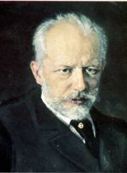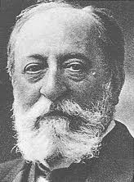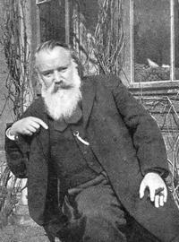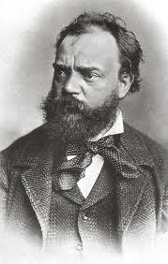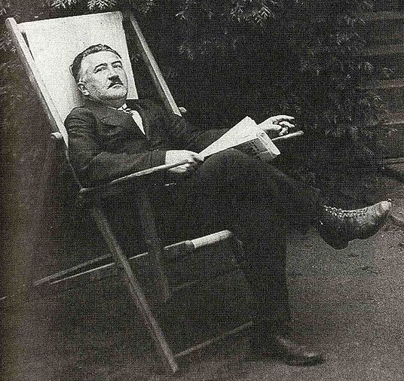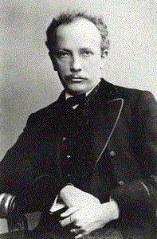
Description: The period from 1840 (Tchaikovsky’s birth) to World War I saw a seismic shift in the agendas and techniques of Romantic composers. The early Romantic generation of Chopin and Mendelssohn had used modest means -- piano solos, lieder, and intimate chamber music -- as a platform for introspective, often quirky, personal expression. Their successors employed far grander means -- opera, ballet, large-scale symphonic works -- for more public, even political expression. Whether obsessed with imperial, nationalistic, or purely philosophical themes, these composers-Brahms, Tchaikovsky, Dvorak, Strauss, Mahler, Bruckner, and others-were as revolutionary as any who came before them.
Week | Biographical and Historical Themes | Featured Works
1 | The Liszt Legacy; The Imperial Style | Tchaikovsky: Swan Lake, Piano Concerto, Romeo & Juliet
2 | The Mighty Handful: Nationalism, Exoticism, Travelogues | Mussorgsky: Night on a Bald Mountain and The Nursery  Borodin: From the Steppes of Central Asia  Rimsky- Korsakov: Sheherezade
3 | The Cataclysmic influence of Liszt and Wagner; The Organ Style and French Nationalism | Frank: Symphony in D Minor  Saint-Saëns: Organ Symphony
4 | Sentimental Pastoralism | Dvořák: Symphonies 7-8
5 | Music as Autobiography; Music in the Twilight | Brahms: Symphony No. 3  Bruckner: Overview of his works
6 | Looking Inward. Reckoning with the Past. Backward with Brahms, Forward with Webern. | Brahms: Late Piano Works Op. 116-119  Brahms: Fourth Symphony (Passacaglia)  Webern: Passacaglia for Orchestra Op. 1
7 | Beethoven’s Fifth: The Next Generation | Mahler: Symphony No. 2  Josef Suk: Asrael Symphony  Brahms:Ein Deutsches Requiem
8 | Retreat from Modernism; Cocoons of the Past | Strauss: Der Rosenkavalier and Ariadne auf Naxos

Recommended Materials
Reinhold Brinkmann, Late Idyll: The Second Symphony of Johannes Brahms
Carl Dalhaus, Nineteenth Century Music
Walter Frisch, Brahms: The Four Symphonies
The New Grove Russian Masters 1: Glinka, Borodin, Balakirev, Musorgsky, Tchaikovsky
Leon Plantinga, Romantic Music: A History of Musical Style in Nineteenth Century Europe
Michael Steinberg, The Symphony: A Listener’s Guide
Richard Taruskin,
- Music in the Nineteenth Century
- Music in the Early Twentieth Century
- Defining Russia Musically

