Graham School of General Studies

Shostakovich
The University of Chicago
John Gibbons
708-393-9729
john@holdekunst.com

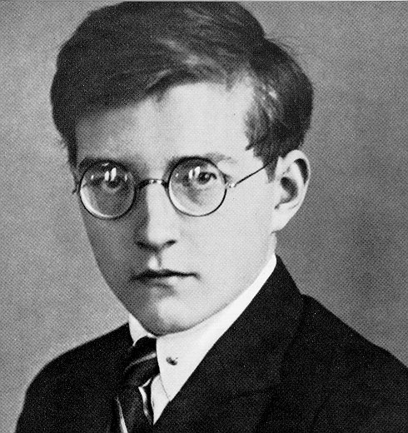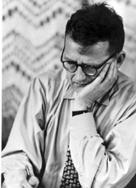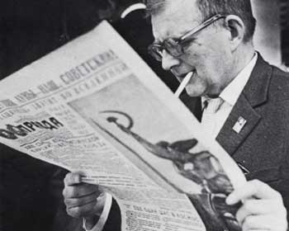
Description: More and more, critics consider the highly controversial Soviet composer Shostakovich to be the most important existentialist composer of the 20th century. A remarkable prodigy who astonished the musical world with his First Symphony, Shostakovich lived during the dangerous political climate of the Stalinist era. He developed a paradoxical style characterized by searing emotional intensity coexisting with politically motivated or mandated paradigms. This class will place the musical content in context, with analysis, lecture, and listening, and survey relevant personal, literary, and journalistic sources. Music literacy is not required.

Week | Biographical and Historical Themes | Featured Works
1 | Shostakovich’s childhood. Crisis and revolution (1917). Conservatory years. | Symphony No. 1 (1925)  The Bolt
2 | Constructivism and stylistic radicalism. Celebrity. | Lady Macbeth of the Mtsensk District (1932)
3 | Accusation of Formalism: “Muddle Instead of Music.” Stalin and the Purges. | Symphony No. 4 (1936)  Symphony No. 5 (1937)
4 | War and its effects. The People’s Artist. | Symphony No. 7 (1941)
5 | Shostakovich as composer of chamber music. Shostakovich confronts anti-Semitism. | Piano Quintet (1940)  Piano Trio No. 2 (1944)  From Jewish Folk Poetry (1949)  String Quartet No. 4 (1949)
6 | “Second Rebuke.” Shostakovich turns inward. | 24 Preludes and Fugue Opus 87 (1951)
7 | “The Thaw.” Shostakovich as the moral conscience of a nation. | Symphony No. 13 (1962)  Cello Concerto No. 2 (1966)
8 | A style of bitterness and desolation. Confronting the Abyss. “Death is not a beginning. It’s the real end. There will be nothing afterward. Nothing.” | Symphony No. 15 (1971)  String Quartet No. 15 (1974)  Sonata for Viola and Piano (1975)

Recommended Materials

Shostakovich: The Illustrated Lives of the Great Composers
by Eric Roseberry

Shostakovich and His World (The Bard Music Festival)
Princeton University Press

A History of Russian Music: From Kamarinskaya to Babi Yar
by Francis Maes

Story of a Friendship: The Letters of Dmitry Shostakovich to Isaak Glikman, 1941-1975

by Dmitry Shostakovich

Shostakovich and Stalin
by Solomon Volkov

Shostakovich: A Life

by Laurel E. Fay

A Shostakovich Casebook (Russian Music Studies)
Indiana University Press

Testimony: The Memoirs of Dmitri Shostakovich (Limelight)
by Solomon Volkov

Shostakovich: A Life Remembered, Second Edition
by Elizabeth Wilson

